C PROGRAMMING PROJECT
NAME: Ratnesha Gupta
SAP ID: 590023288
Batch – 46

TEST OUTPUTS
- When the code is executed
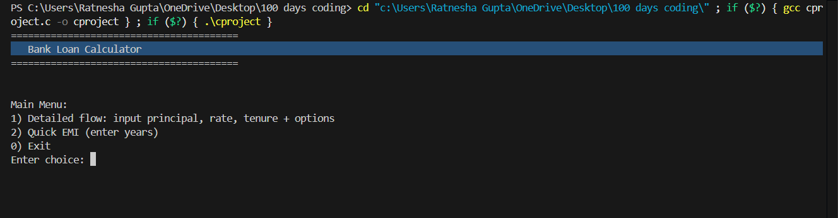

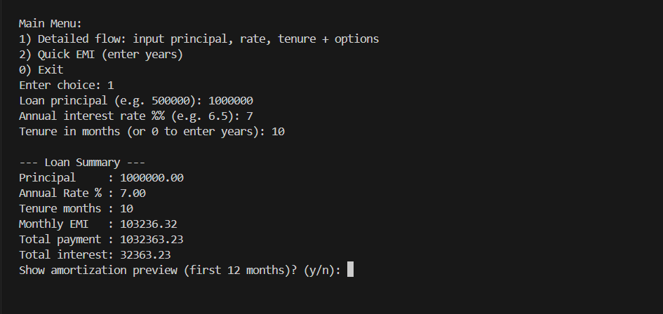
2.When we are choosing the first option (1)

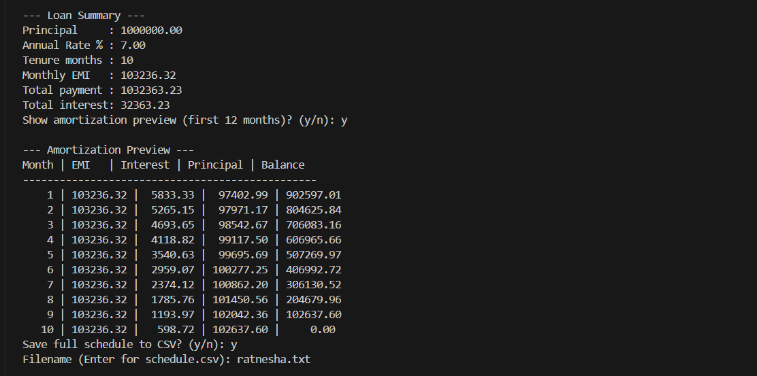
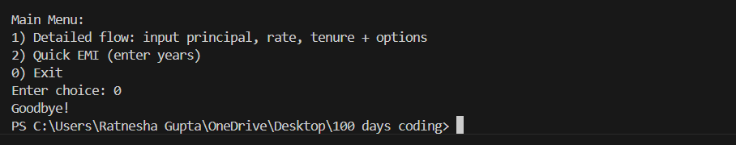
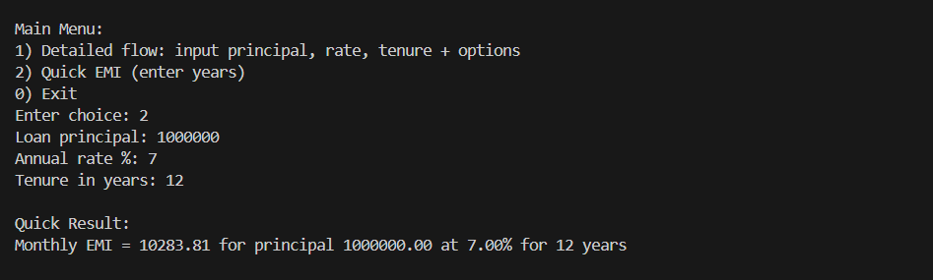
3.When we are choosing the second option (2)

4.when we choose 0

